# User interface

The user interface exists out of five layers. *Italic texts are new ideas/comments.*

## Office screen

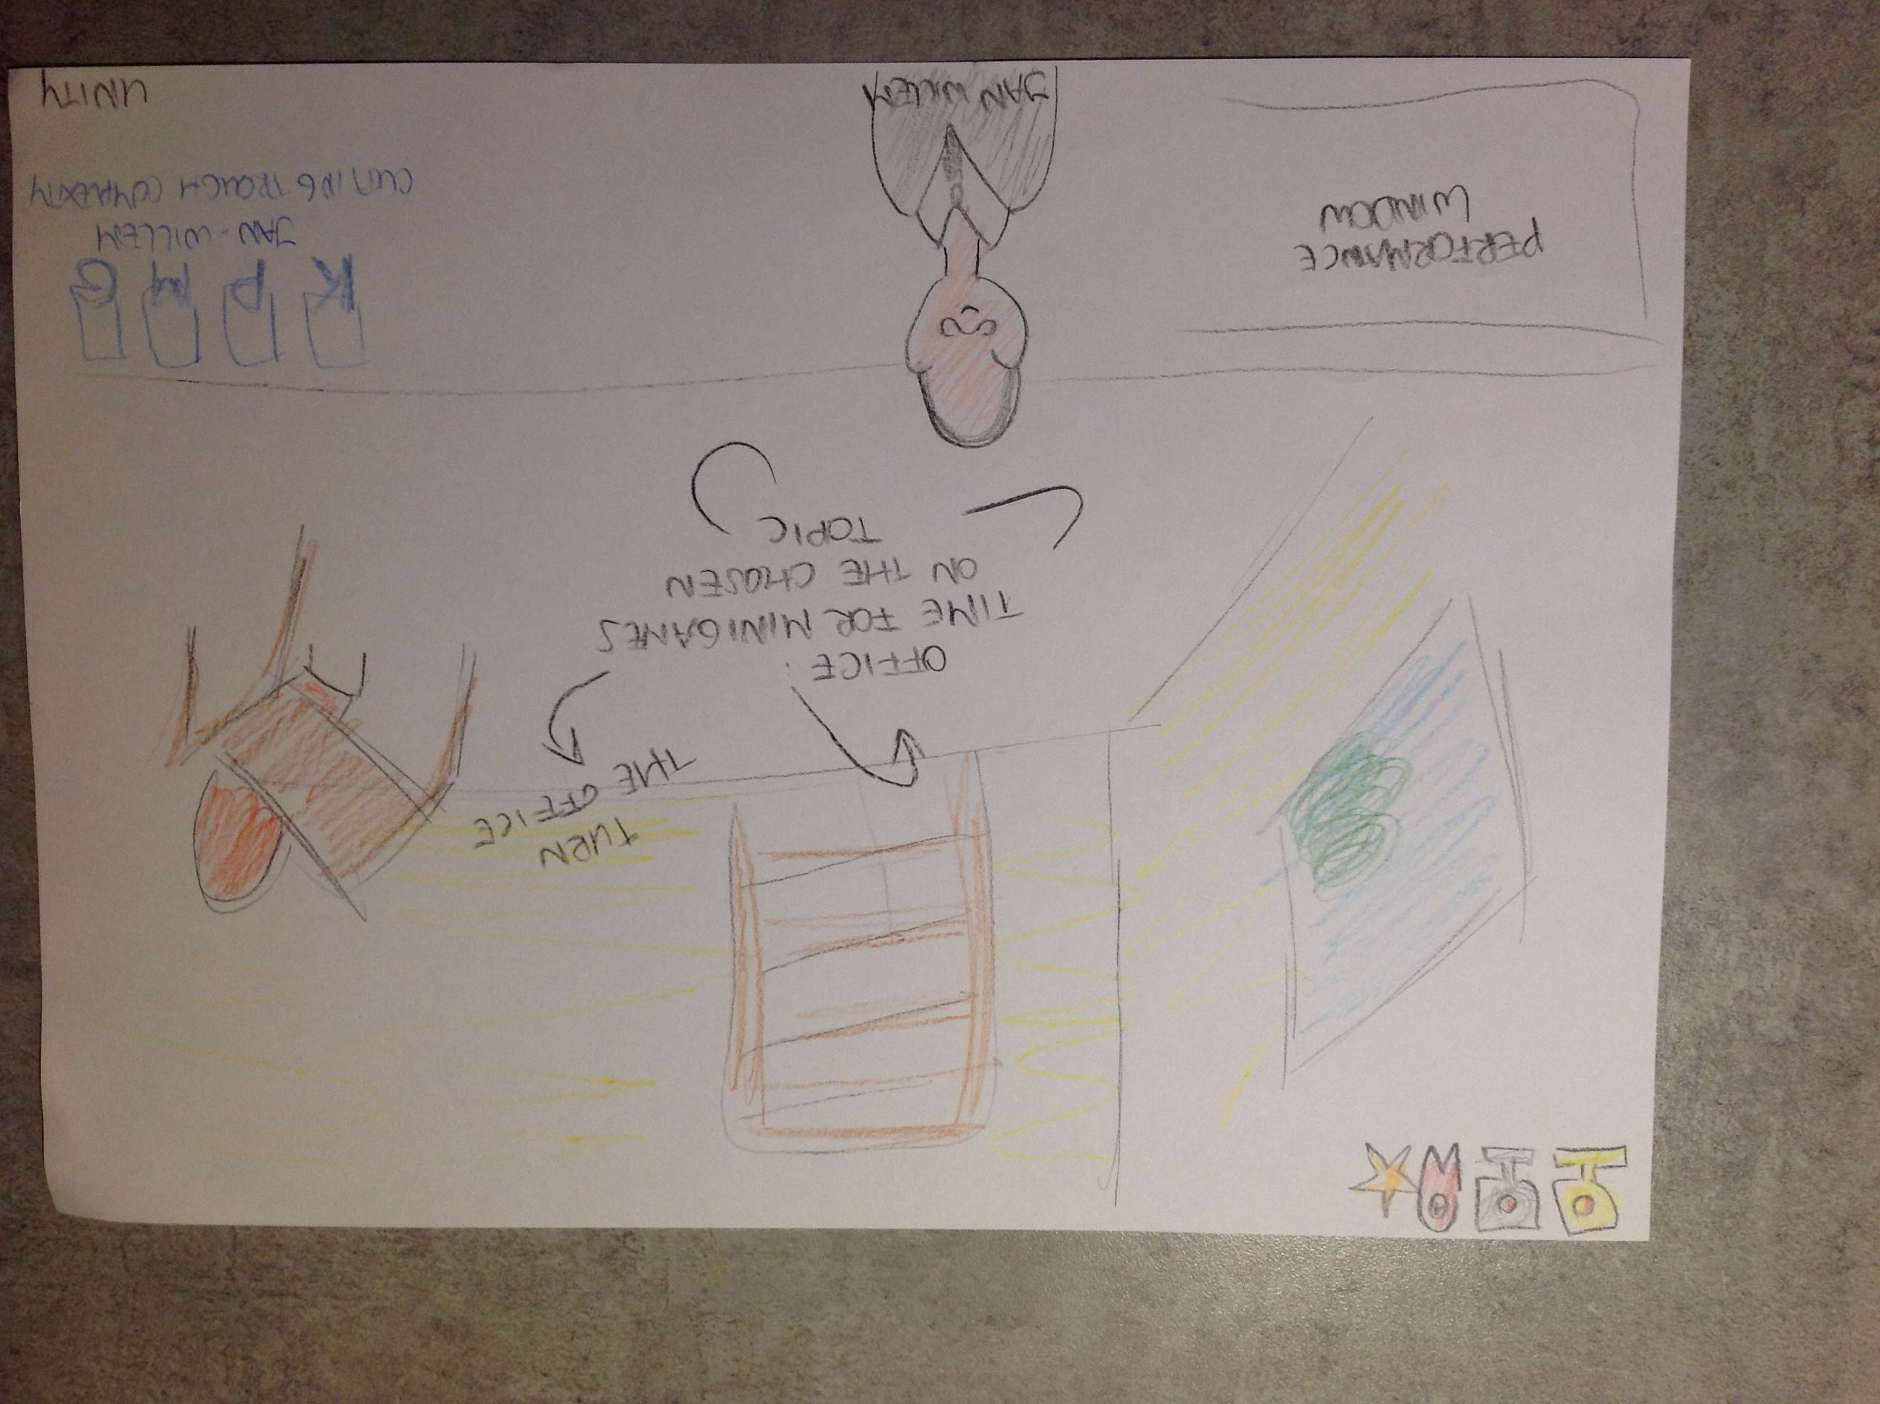

* In the office is a trophy case where all trophies are displayed with all information about them. (also the ones not earned yet).
* There is a Big screen/window, when you click on it, it displays extended personal statistics (average tries, hours in game, etc)
* On the desk is a PC with messages, deadline and new missions

## Neighbourhood screen

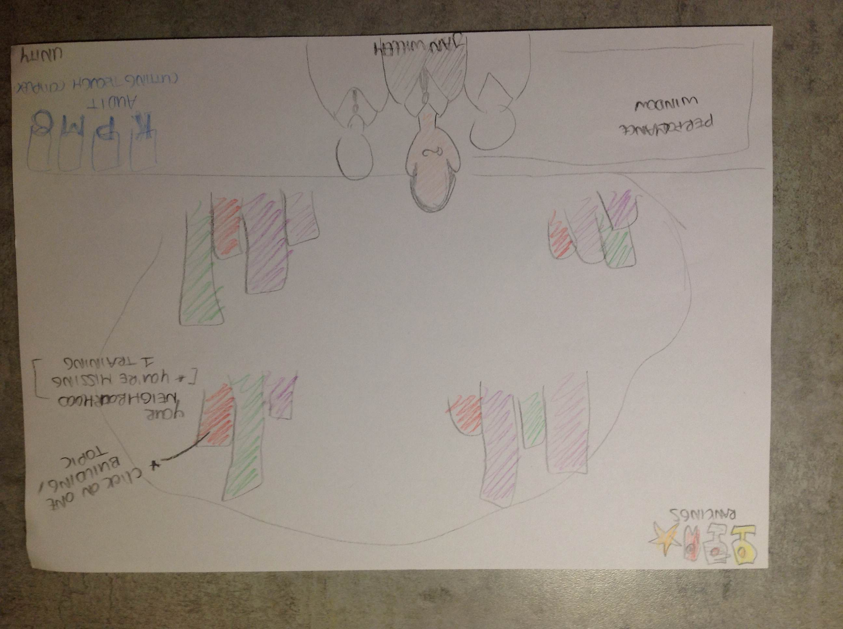

* Click on own buildings for mission log per topic and replay.  
  *Maybe also new missions?*
* Click on other buildings to see general score of other players  
  *Names?  
  Avatars?*
* Add a department building for:  
  *Dep. Missions?  
  Dep. Trophies?*

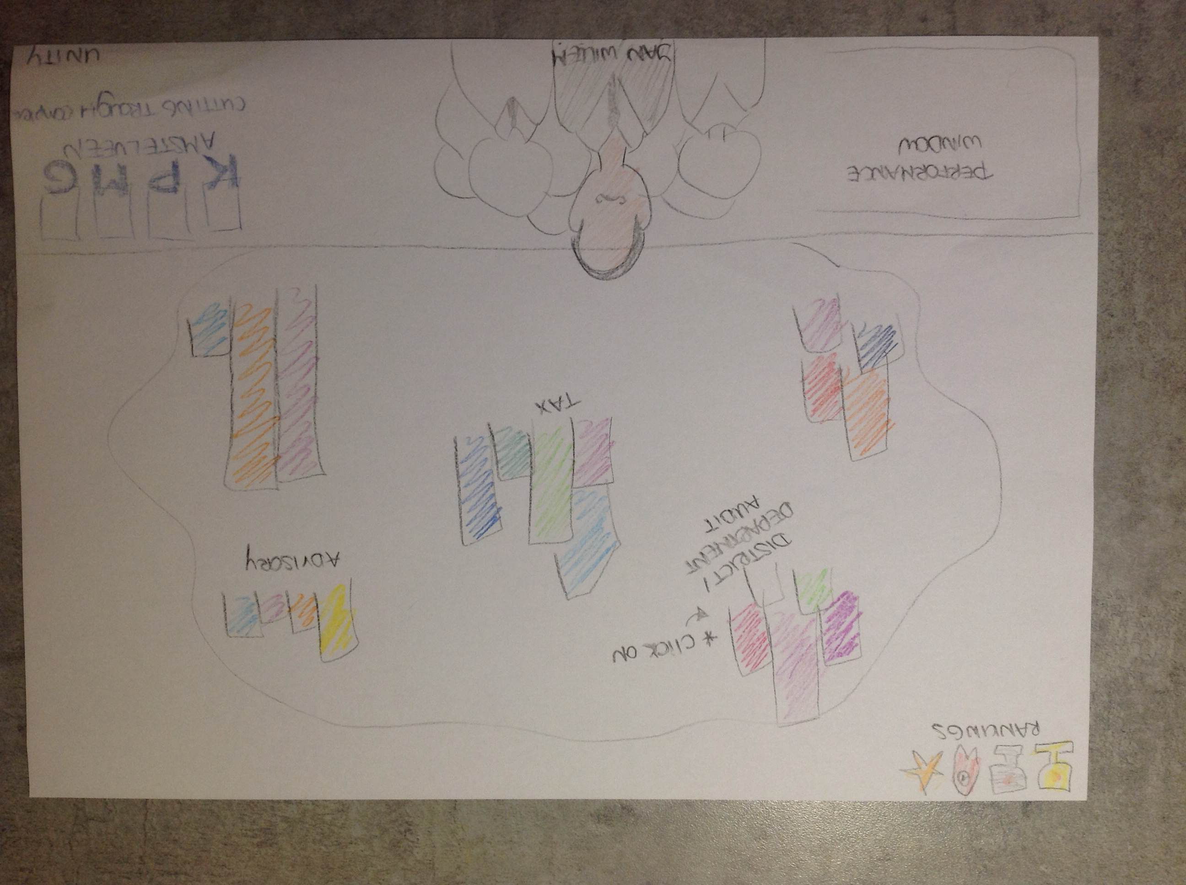

## City screen

* Click on own department/neighbourhood to see department statistics.
* Click on other department to see department statistics, hold over for sum of scores  
  *needed topics might be different per dep. Hard to compare?*
* *Add comparison tool?*

## Country screen

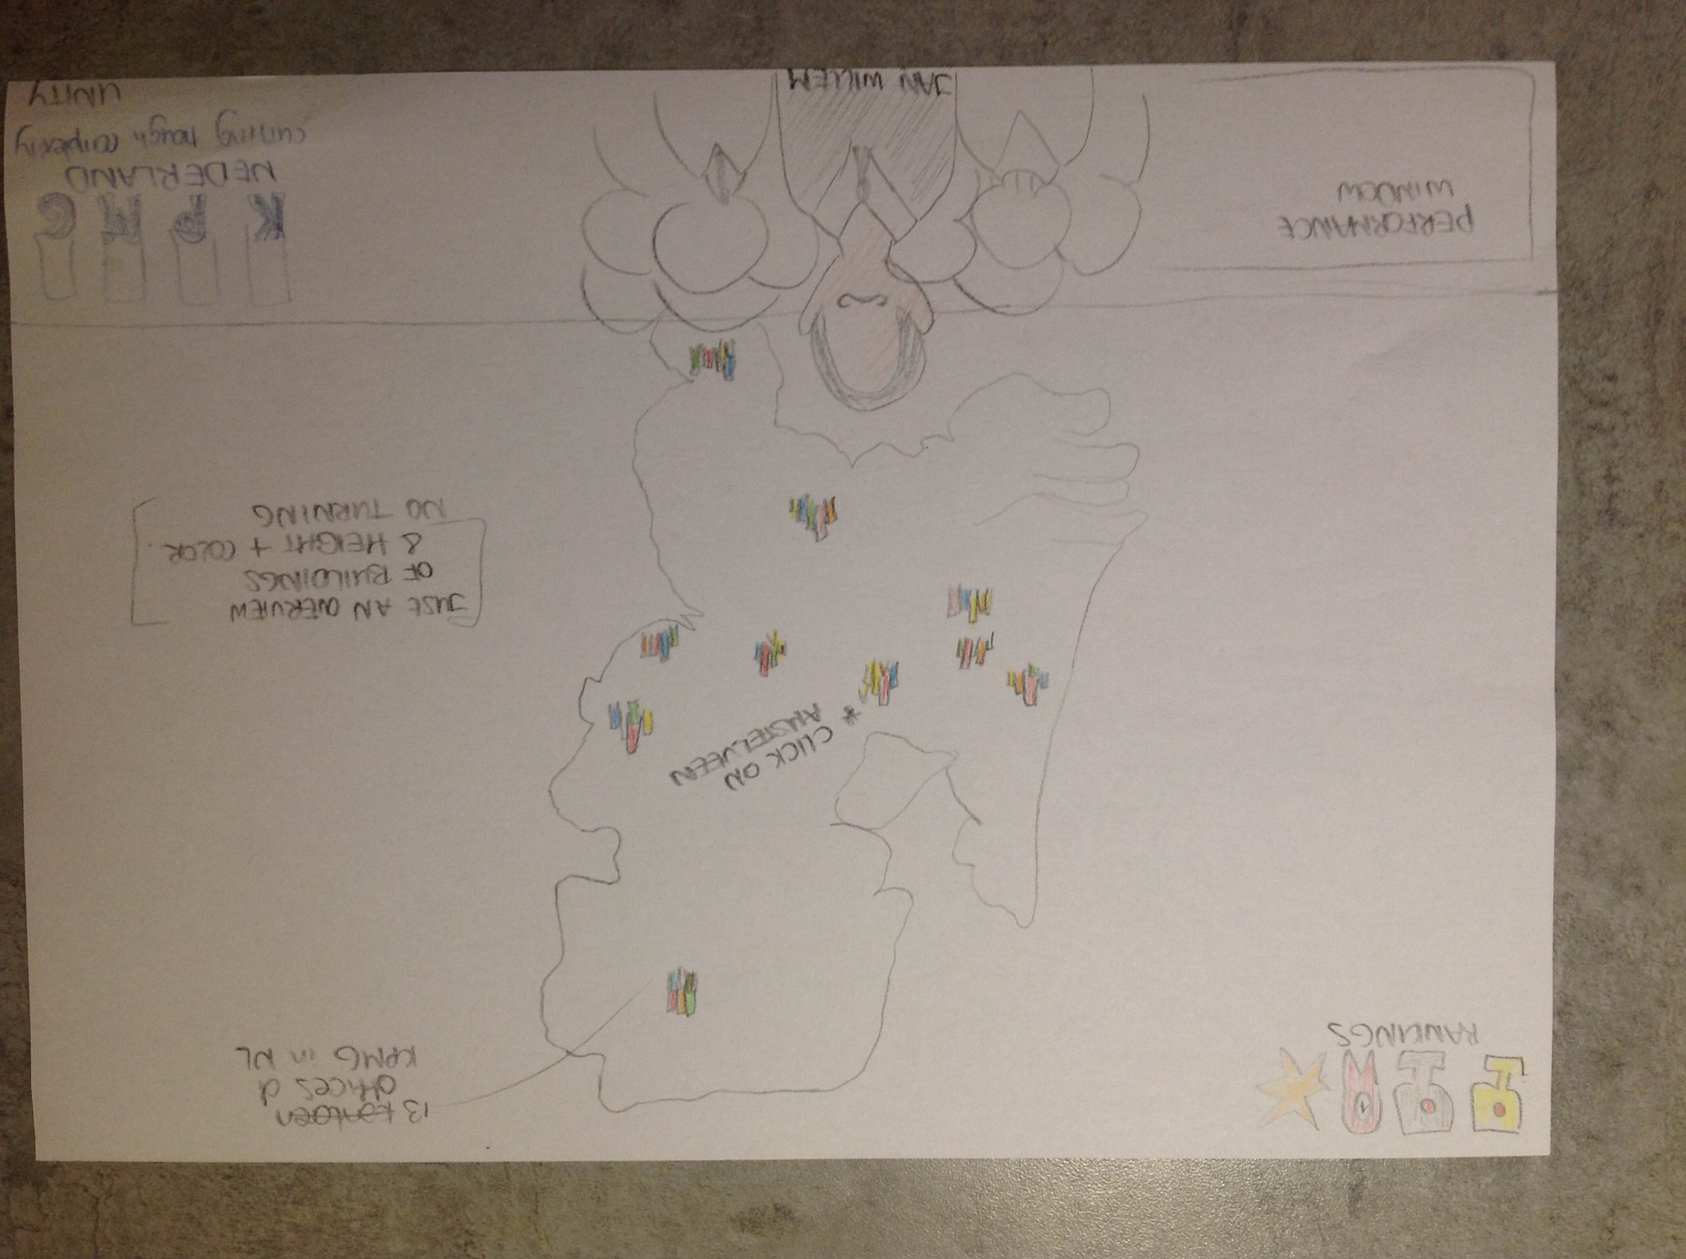

Same as city screen, but then offices instead of departments

## World screen

* Same workings as city and country screen.

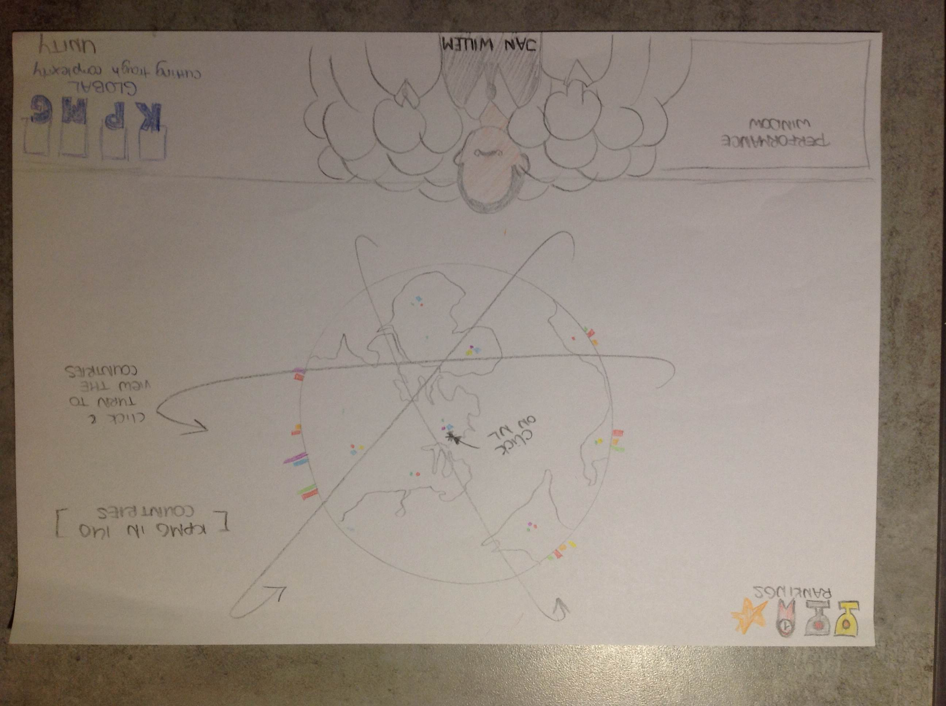

* Numbers are summed/averaged per country.
* *This will make three “statistics screens” in the interface. Maybe give them more content by:*
  + *New external mission at office, “travel” to the right country/office using the country/world screen, play minigame there?*
  + *Challenge colleagues, departments or other offices in a minigame?*

## Status bar

* The bar stays (almost) the same at each screen

**5**

**3**



**4**

**2**

**1**

1. Window that shows performance/current mission/upcoming deadlines
2. Your avatar
3. Shadows/avatars of colleagues on the current layer. (*what is easier/nicer)*
4. Menu buttons (settings, main menu, save, etc)
5. Buttons to go to the different layers (incorporated in the logo)